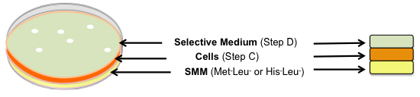
Figure S2. Three overlay plates

